



|Voyages Ecuador 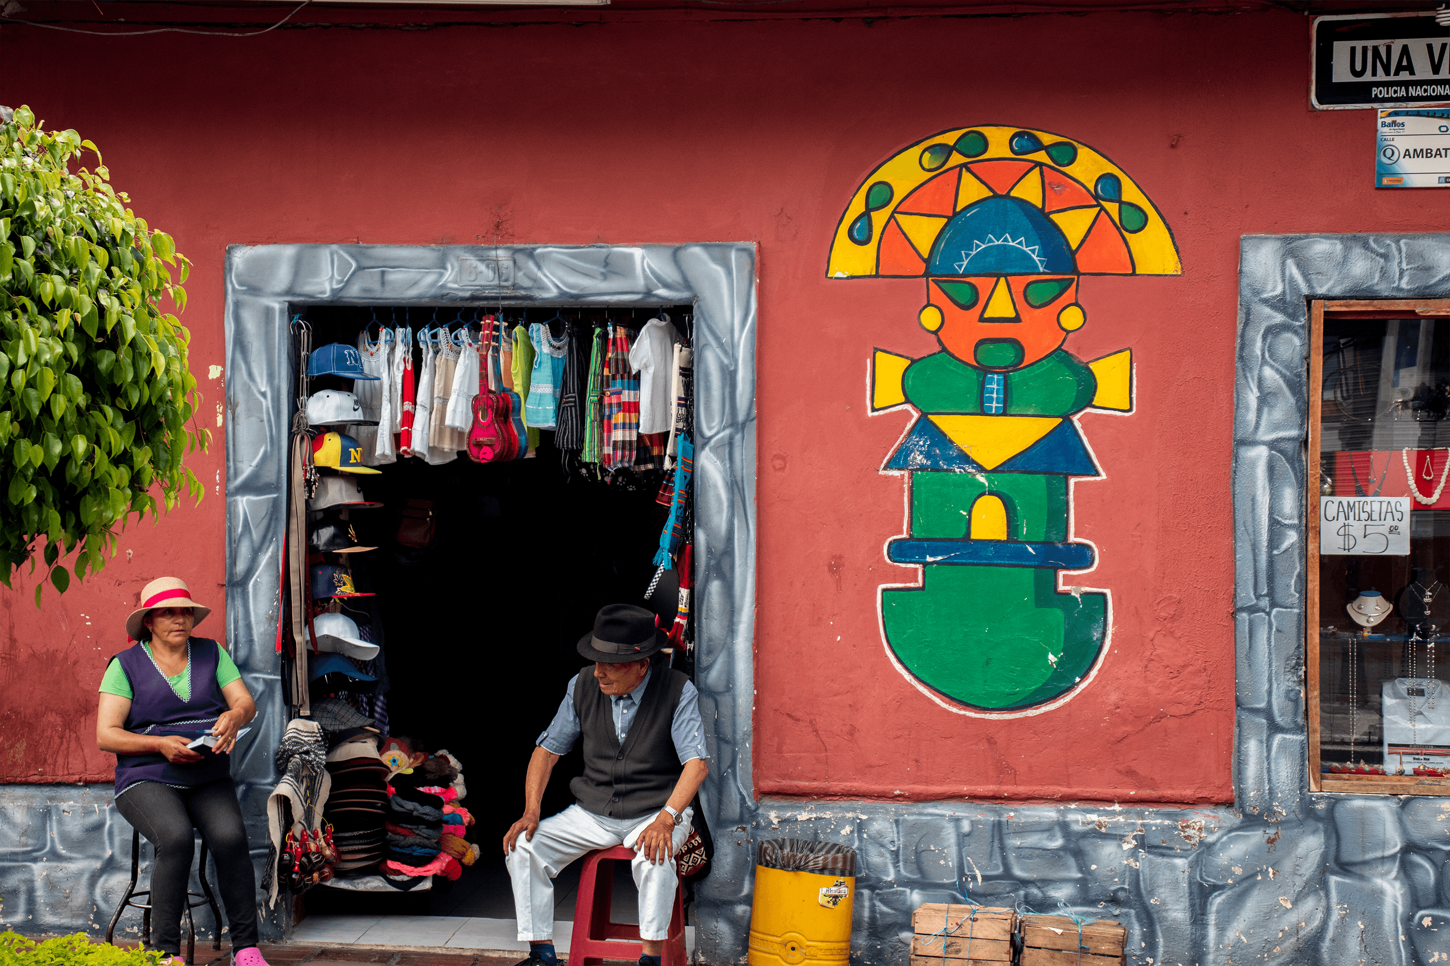

**Program:** Quito

**|**Quito, in full Villa de San Francisco de Quito, city and capital of Ecuador. It is situated on the lower slopes of the volcano Pichincha, which last erupted in 1666, in a narrow Andean valley at an elevation of 9,350 feet (2,850 meters), just south of the Equator. The oldest of all South American capitals, Quito is notable for its well-preserved old town, which was designated a UNESCO World Heritage site in 1978 **|**

**Requested by:**  Lilla Nedeczky

**Pax** **Number**: 6

**Tour** **Length** 2 Days

**Tour** **Start** **Date**: October 23rd 2021

**Guide** **language**: English

| Quito

**Day 1:** Mitad del Mundo

On this day we will head north from Quito to visit the “Middle of the World” monument and Intinñan Museum. We first head out to Quito’s outskirts to enjoy the “Intiñan” museum, where you can witness the supernatural powers and magnetic forces the equator offers. Here you will also see the most geographically accurate, GPS-tracked equator line. After that, you will also see the previously placed Equator line at the more recognized Middle of the World monument. After these two amazing visits, we will finish the day in Casa Agave, and interesting museum where we learn about important Agave plant in Ecuadorian Culture. We will then head back to Quito.

**Included**:Private transportation, English & Spanish speaking guide, entrance fees.

**Day 2:** Full day Otavalo

Driving northwards from Quito, your trip begins in the town of Calderon where we find the well-known bread-dough figures and decorations known as “masapan”. In the way to Otavalo we visit The Quitsato Sundial is the first and only Monument of the Middle of the world, which is exactly on the Equatorial Line or Zero Parallel. It is a large sundial of 52 meters in diameter, made with a large stone mosaic that indicate the different lines of the solstices and equinoxes, as well as the hours of the day, these are marked by means of the projection of the shadow of a Large 10 meter high pole that is exactly in the center of this large circular platform. As we approach Otavalo and before we arrive in the province of Imbabura, also known as “the Province of Lakes”, you will have stunning views of the San Pablo Lake with the high peak of Imbabura Volcano behind it. Our next stop is the town of Otavalo, home of the largest indigenous market of its kind in South America. You’ll arrive just in time to bargain for beautiful tapestries, local paintings, hand-knitted wool sweaters, socks and gloves, wood carvings, silver jewelry, embroidered blouses and straw hats, to name only a few of the items on offer. After lunch (on your own) in one of the local haciendas, we head for Cotacachi, a town renowned for its handmade leather goods. If time allows, we will also visit Cuicocha, an ancient, eroded volcanic crater famous for the deep lake found within it. In our way, back to Quito, we stop at the city of Cayambe, where we invite you to try the local specialty: biscuits or “Biscochos”. Return to Quito.

**Included**:Private transportation, English & Spanish speaking guide, entrance fees

| 2021 Net Prices per Person

|  |  |
| --- | --- |
| Pax: | 6 |
| Price p.p. | $ 100 |

**Included:** Private transportation, English/Spanish speaking guide, entrance fees.

**Not included**: Extras, tips, beverages, personal expenses, travel insurance, meals, IVA.

**Grading:** Easy

**|General Reservation Policies:**

Once the client confirms their interest in the offered touristic package, Ecoandes Travel will block services, such as hotels and tours in order to secure what was initially proposed. Providers generally set a time limit until which Ecoandes Travel needs to confirm or cancel the blocked services. This time limit can be extended under certain circumstances. In case, it is not an option, and the client is yet unable to confirm the tour, Ecoandes Travel will look for alternative services of the same category. Upon confirmation, our general payment and cancellation policies apply.

**|General Payment Policies:**

* 20% Deposit to be paid upon confirmation.
* Balance to be paid 65 days before the tour starts.

**|General Cancellation Policies:**

* Until 65 days prior arrival: No Fee
* Between 64-60 days prior arrival: 30% Penalty
* Between 59 – 46 days prior arrival: 50% Penalty
* Within 45 days prior arrival: 100% Penalty

***Since 1991, Creating Lifetime Experiences***

ECUADOR | PERU | BOLIVIA | CHILE | ARGENTINA